To Dr. Audrey Alignier,

We thank the reviewers for their comments (shown below in italics), and have amended the manuscript accordingly. In addition to minor corrections, our changes to the manuscript were:

- Creating and running yearly models to make sure that effects were not dependent on year (added to tables in supplemental)

- Justifying the use of single visits, as well as providing information on seasonal variation in visitation (also added to supplemental)

- Justified leaving out wind pollination as a factor in the study

- Reduced word count by 5% - as noted below, we would be willing to consider a further reduction in text if the editor and reviewer deem this necessary

Thank you for your consideration, and we look forward to hearing from you.

Sincerely,

Samuel Robinson

Ralph Cartar

Stephen Pernal

Riley Waytes

Shelley Hoover

Response to reviewer 1

*The objectives and rationale of the study are clearly stated, except for the use of the term "black box." I think this needs explanation because it is a term I am not familiar with in this context. After I looked up the term, I better understood why it was used.*

A black box refers to a system of known inputs and outputs where the intervening steps are obscured. We have provided a short definition in the first paragraph of the Introduction (line 41).

*1. I don't see that authors included any sort of analysis for possible year effect. Data were collected over 3 years, with commodity fields in Years 1 & 2, and seed fields in Years 2 & 3. If there were differences in weather between years, data on plants, seeds, flowers, and bees (abundance and behaviour) could have been highly impacted and resulted in some of the differences found. How can the authors be sure that results are not due to annual variation? Can/were data analyzed for fields in years 1 & 2 and then for 2 & 3 for only commodity and only seed fields, respectively, to look for a year effect?*

This is a fair point, and we re-ran both models with data from each year separately to check that the conclusions were robust across years (see revised Table S4 and S5 in supplemental). Some terms did differ across years, but they either a) were variance terms, which were not part of our formal study, or b) differed in effect size but not in direction, meaning that while some effects may be stronger during some years, the process is similar. We added a sentence in the Methods section describing this (line 220).

*2. Why were insect visitation and pollution data only collected once in each field? Were all fields blooming at the same time and with the same proportion of flowers open? Were all LCBs emerged at that time and so at the same actual bee densities?*

* As in all field work scenarios, we were faced with a trade-off between collecting large amounts of data from a few sites or fewer data from a larger number of sites. We opted for the latter, as we felt that generality among crop fields was a more important factor than site-specific information, and have added a sentence (line 170) in the Methods section describing this.
* Field bloom varies depending on planting date, but most growers in our region plant during the same time of year (early May). We controlled for variation in the amount of open flowers using the Flower Density term in both models, and found that it tended to affect LCB visitation rather than HB visitation (see Table S5, LCB Visits ~ Flower density).
* Beekeepers take cocoons out of cold storage and place them in fields to coincide with start of bloom in each individual field (as directed by agronomists). Because of this, LCBs emerge at approximately the same time relative to bloom, but the reviewer is correct that bee densities may change across the course of the bloom as adults ecclose, provision cocoons and then die. This change over time was incorporated into the random intercept term in both the HB and LCB visitation models, and there was some decrease over time during 2015 (see figure below), but this did not change our overall results. We added a sentence to the Method section describing this (line 205) and have added this as Figure S3 in the supplemental.

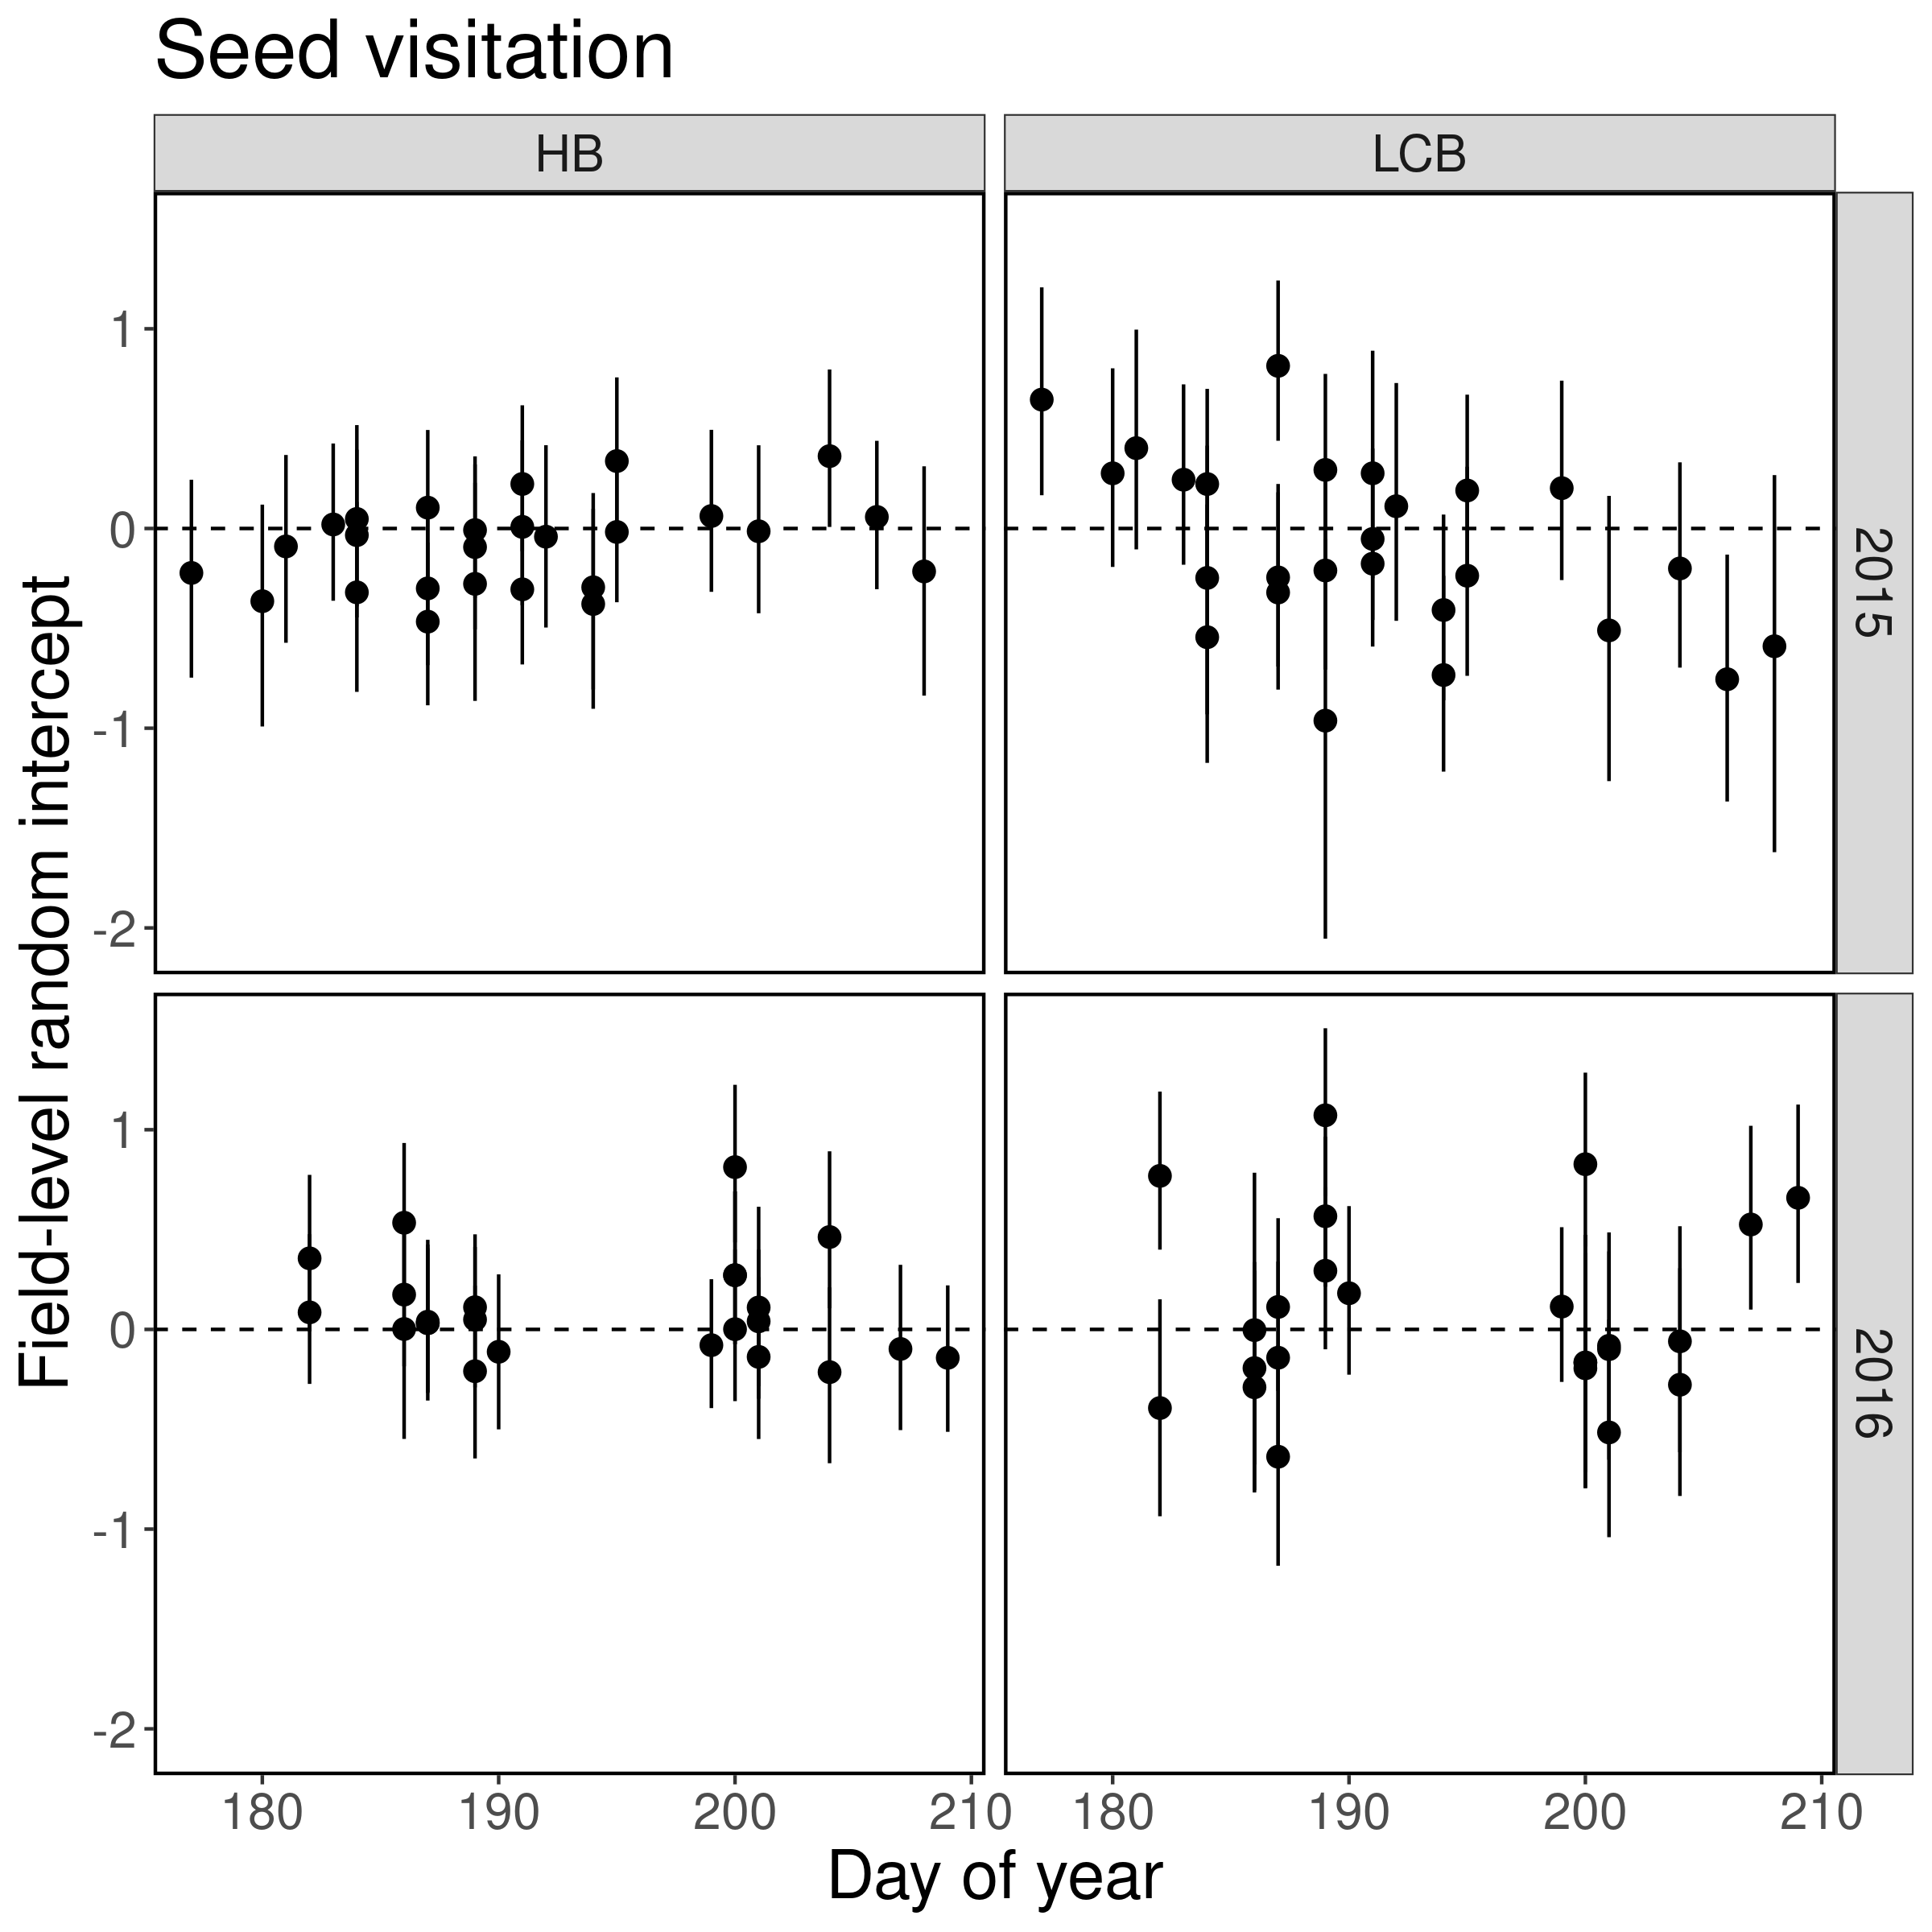

*I have added minor comments and editorial suggestions in the attached PDF.*

We have corrected the minor editorial mistakes listed in the attached PDF (largely spelling or formatting errors) on lines 36, 109, 128, 129, 139, 141, 147, 159, 286, 336, and 379, as well as Figure 2 and 5 captions of the original manuscript. Other comments are listed here:

141: *Are commodity and seed fields planted at different seeding rates to have less dense stands for hybrid fields?* Generally, no. This information is shown in Table S1.

150: Replace “alfalfa leafcutter bee” with LCB throughout manuscript

150: Cocoons are placed inside shelters before adults emerge

170: We opted for sampling more fields rather than multiple samples per field; see our response above.

181: Correct, we recorded plant density at the same plot. We re-organized the sentence to make this clear.

187: We re-ran models for each year of data: see our response above.

Response to reviewer 2

*It isn’t until line 409 that authors mention wind as a potential effect in their design or results. I appreciate the attention to plant physiology and size as under-studied contributors to pollination outcomes, but the authors seem to have missed the chance to appraise wind pollination that has been known in rape since the 1980s. Just a word, perhaps, to explain why or why not this was excluded. I know they critique bagging techniques, but some applied technology could have addressed this question at a replicable scale per plot.*

We decided to forego studying wind pollination in both crop systems, as it is very difficult to separate wind pollination effects from wind-assisted self pollination without the use of genetic methods, and studies that have done so generally find that wind pollination is minimal in most *B. napus*.

* *Brassica* flowers are primarily adapted for pollen transfer by insects, as their pollen is sticky and clumping, and their sigmas are peg-like rather than feather-like (common in wind-pollinated grasses). Because of this, the impact of wind pollination on seed and pod production is generally very low (Pierre and Renard 2010, Perrot et al. 2018), and may even require insects to dislodge pollen from the stamens (Eisikowitch 1981, Pierre et al 2008).
* Most *Brassica* pollination studies have some kind of experimental flaw that either a) fails to fully separate the effect of self-pollination from wind pollination, b) ignores the fact that plants can reallocate resources from poorly-pollinated branches or flowers to well-pollinated ones, c) ignores shading effects from mesh exclosure nets, or d) ignores differences between greenhouse trials and field trials. This is complicated further by the fact that the varieties used in earlier pollination trials have different pollination requirements (modern varieties generally do not benefit from extra bee pollination, Adamidis et al 2019).

To justify ignoring wind pollination, we ran a separate “minimum visitation” scenario for seed fields, where we set visitation to zero and HB/LCB distances to their maximum observed values in order to gauge pollen deposition under “minimal visitation”. Predicted pollen deposition was only 3.5 grains/stigma, and we have added a line in the Methods section explaining this (L 194).

*Not seeing anywhere else to put this - but on Line 165 and thereafter it should be "Waytes et al."*

Corrected.

*It is on the long side. I think thoughtful editing could reduce it 10%*

We reduced the non-bibliography word count from 6792 to 6385 (5%), but because the topic is multi-faceted and sometimes complicated, we were hard-pressed to make further reductions without removing (what we consider to be) important information. If the editor and reviewer have any suggestions about what particular sections could be pruned or moved to the supplemental, we would consider a further 5% reduction.